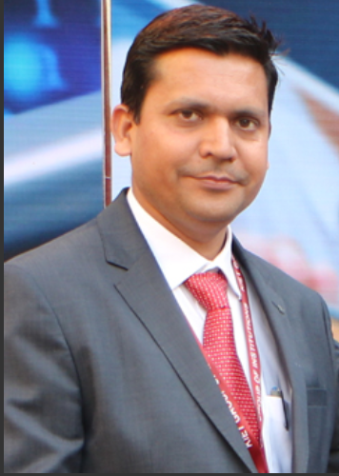
Dr. Ajay Kumar Shrivastava
Professor & Dean
The Department executes 4 years B.Tech. Degree Course. It has state-of-the-art & world class facilities, with a clear aim to be known as one of the best departments in Computer Science among all existing Indian colleges of repute.
The department has a strong team of faculty members with high dedication towards their commitment in teaching and research.
The final year students of the department are performing extremely well in the placement activities and have been placed in almost all the leading organizations and making the name of the department sparkle. I am sure the department will meet its vision and mission in the best manner.

